USB/Thunderbolt/Serial

🔌 What Are USB / Thunderbolt / Serial Cables in Networking?
# Source: AI Source: Provided by: [Data Path: Persons Table -> ID Column: 1, Name_En Column: Motasem Essam] -> From: [ChatGPT] on [12/18/2025]
USB, Thunderbolt, and Serial cables are general-purpose data cables, but in networking, they are mainly used for management, configuration, or device-to-device communication — not for standard LAN traffic.

📦 Belongs to:
# Source: AI Source: Provided by: [Data Path: Persons Table -> ID Column: 1, Name_En Column: Motasem Essam] -> From: [ChatGPT] on [12/18/2025]
✅ Types of Network Cables (Non-Ethernet)
Specifically for device control, setup, or specialized links, not typical network data transfer.

🧾 Breakdown of Each:

🟦 1. USB (Universal Serial Bus)
# Source: AI Source: Provided by: [Data Path: Persons Table -> ID Column: 1, Name_En Column: Motasem Essam] -> From: [ChatGPT] on [12/18/2025]
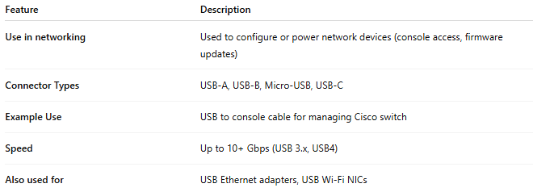
Feature | Description
Use in networking | Used to configure or power network devices (console access, firmware updates)
Connector Types | USB-A, USB-B, Micro-USB, USB-C
Example Use | USB to console cable for managing Cisco switch
Speed | Up to 10+ Gbps (USB 3.x, USB4)
Also used for | USB Ethernet adapters, USB Wi-Fi NICs

USB Image
# Source: ScreenShots Source: Provided by: [Persons Table -> ID Column: 1, Name_En Column: Motasem Essam] -> Tool: [Lightshot Program] -> From [Site: Google Search: Images: usb cable] on [12/18/2025]
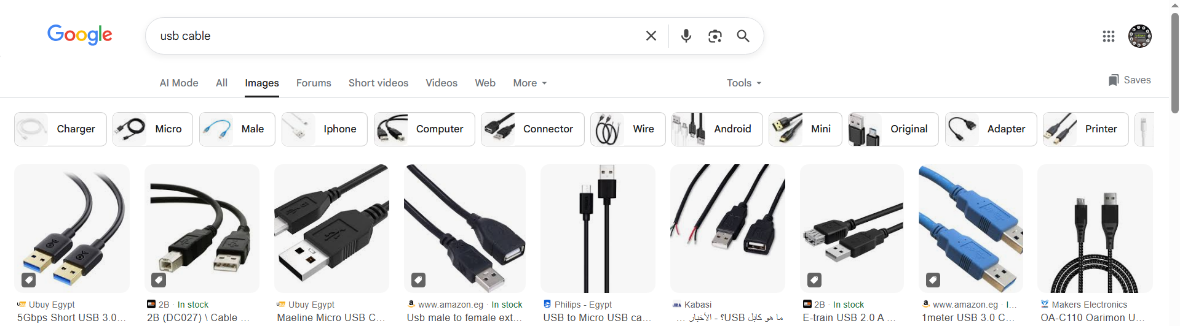

⚡ 2. Thunderbolt
# Source: AI Source: Provided by: [Data Path: Persons Table -> ID Column: 1, Name_En Column: Motasem Essam] -> From: [ChatGPT] on [12/18/2025]
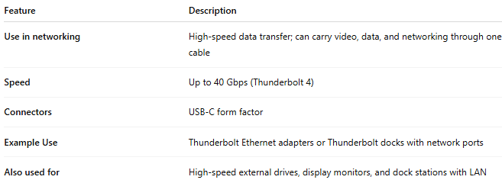
Feature | Description
Use in networking | High-speed data transfer; can carry video, data, and networking through one cable
Speed | Up to 40 Gbps (Thunderbolt 4)
Connectors | USB-C form factor
Example Use | Thunderbolt Ethernet adapters or Thunderbolt docks with network ports
Also used for | High-speed external drives, display monitors, and dock stations with LAN

Thunderbolt Image
# Source: ScreenShots Source: Provided by: [Persons Table -> ID Column: 1, Name_En Column: Motasem Essam] -> Tool: [Lightshot Program] -> From [Site: Google Search: Images: Thunderbolt cable] on [12/18/2025]
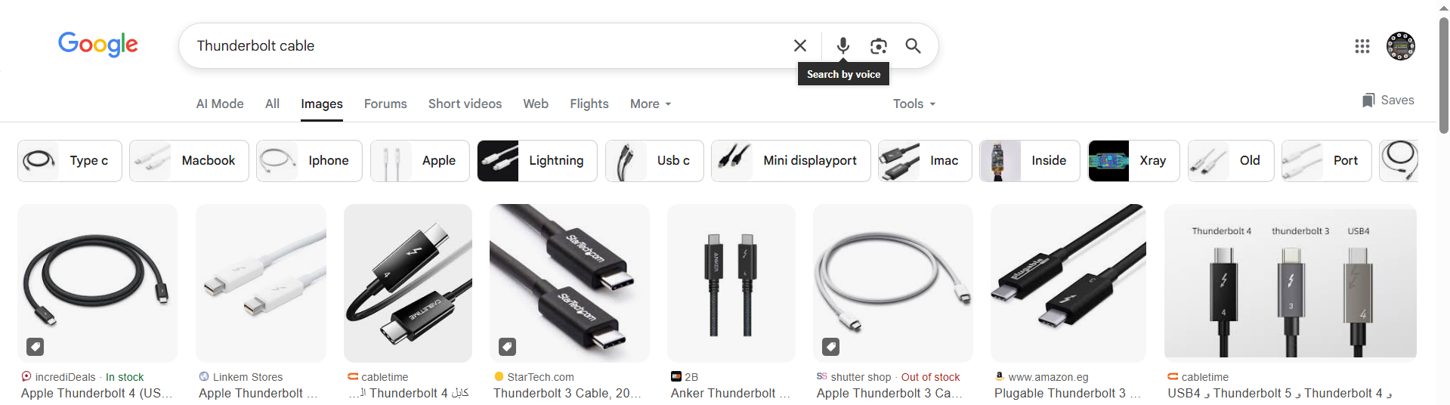

🔘 3. Serial (RS-232)
# Source: AI Source: Provided by: [Data Path: Persons Table -> ID Column: 1, Name_En Column: Motasem Essam] -> From: [ChatGPT] on [12/18/2025]
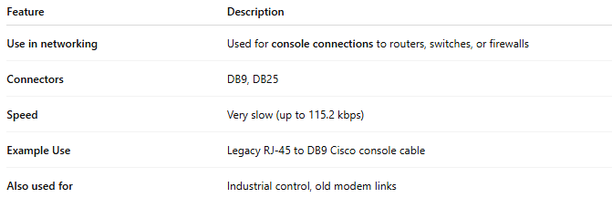
Feature | Description
Use in networking | Used for console connections to routers, switches, or firewalls
Connectors | DB9, DB25
Speed | Very slow (up to 115.2 kbps)
Example Use | Legacy RJ-45 to DB9 Cisco console cable
Also used for | Industrial control, old modem links

Serial (RS-232) Image
# Source: ScreenShots Source: Provided by: [Persons Table -> ID Column: 1, Name_En Column: Motasem Essam] -> Tool: [Lightshot Program] -> From [Site: Google Search: Images: Serial (RS-232) cable] on [12/18/2025]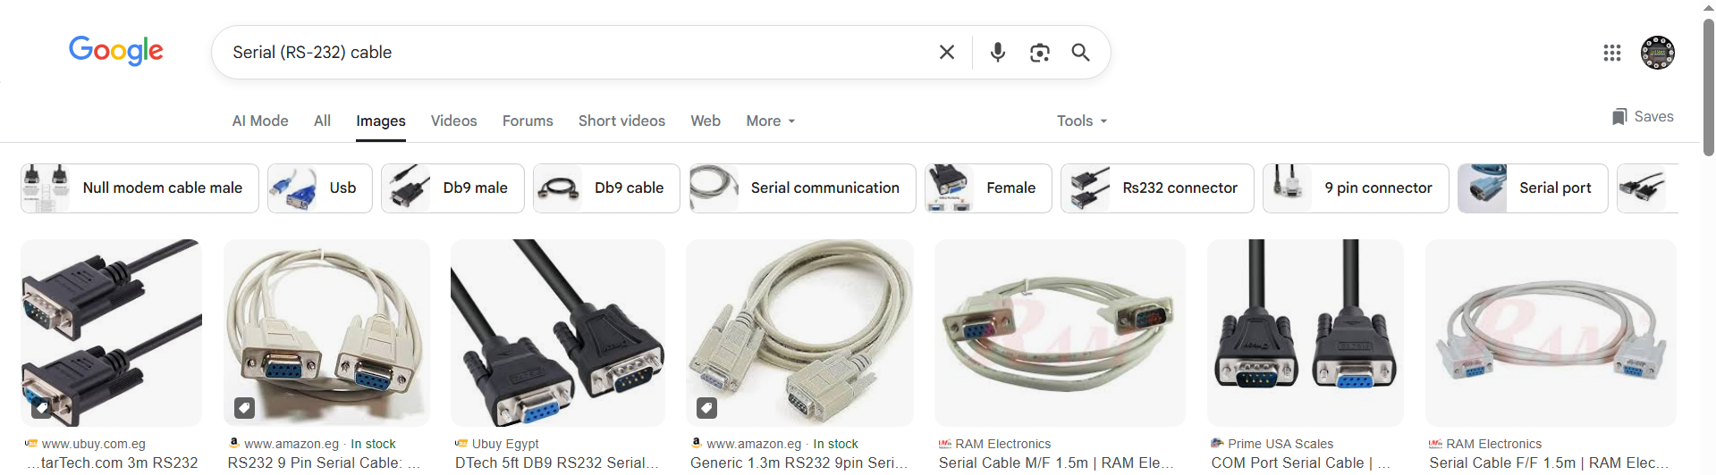

📌 Summary Comparison
# Source: AI Source: Provided by: [Data Path: Persons Table -> ID Column: 1, Name_En Column: Motasem Essam] -> From: [ChatGPT] on [12/18/2025]
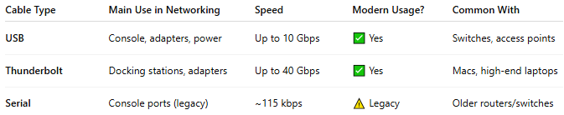
Cable Type | Main Use in Networking | Speed | Modern Usage? | Common With
USB | Console, adapters, power | Up to 10 Gbps | ✅ Yes | Switches, access points
Thunderbolt | Docking stations, adapters | Up to 40 Gbps | ✅ Yes | Macs, high-end laptops
Serial | Console ports (legacy) | ~115 kbps | ⚠️ Legacy | Older routers/switches

✅ Use Cases in Networking
# Source: AI Source: Provided by: [Data Path: Persons Table -> ID Column: 1, Name_En Column: Motasem Essam] -> From: [ChatGPT] on [12/18/2025]
- 🧰 Configuring switches via USB to Console
- 🖧 Adding Ethernet ports via USB or Thunderbolt adapters
- 🔧 Troubleshooting older devices via Serial COM port

